**Task – 1:**

**Problem Statement:** You work for XYZ Corporation. Their application requires a storage service that can store files and publicly share them if required. Implement S3 for the same.

**Tasks To Be Performed:**

1. Create an S3 Bucket for file storage.

2. Upload 5 objects with different file extensions.

Created a bucket named “mys3bucket2000”

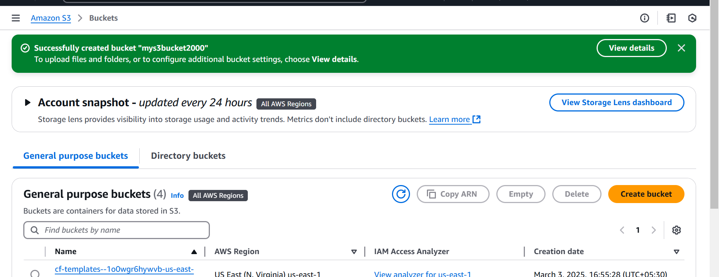

Uploaded 5 objects with different files in the bucket

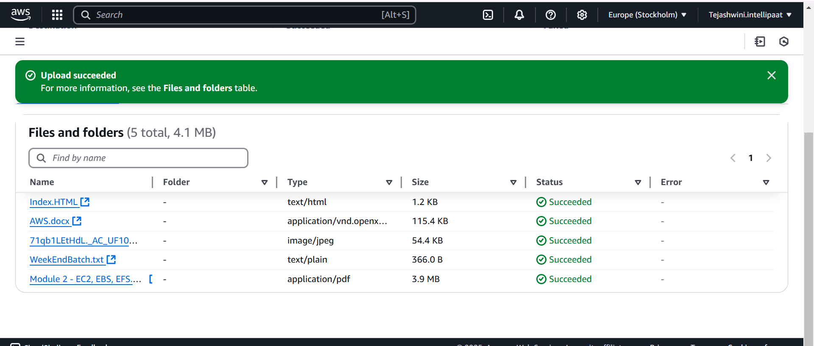

**Task – 2**

**Problem Statement:**

You work for XYZ Corporation. Their application requires a storage service that can store files and publicly share them if required. Implement S3 for the same.

**Tasks To Be Performed:**

1. Enable versioning for the bucket created in task 1.

2. Re-upload any 2 files already uploaded to verify if versioning works

Bucket versioning enable for bucket created in task 1

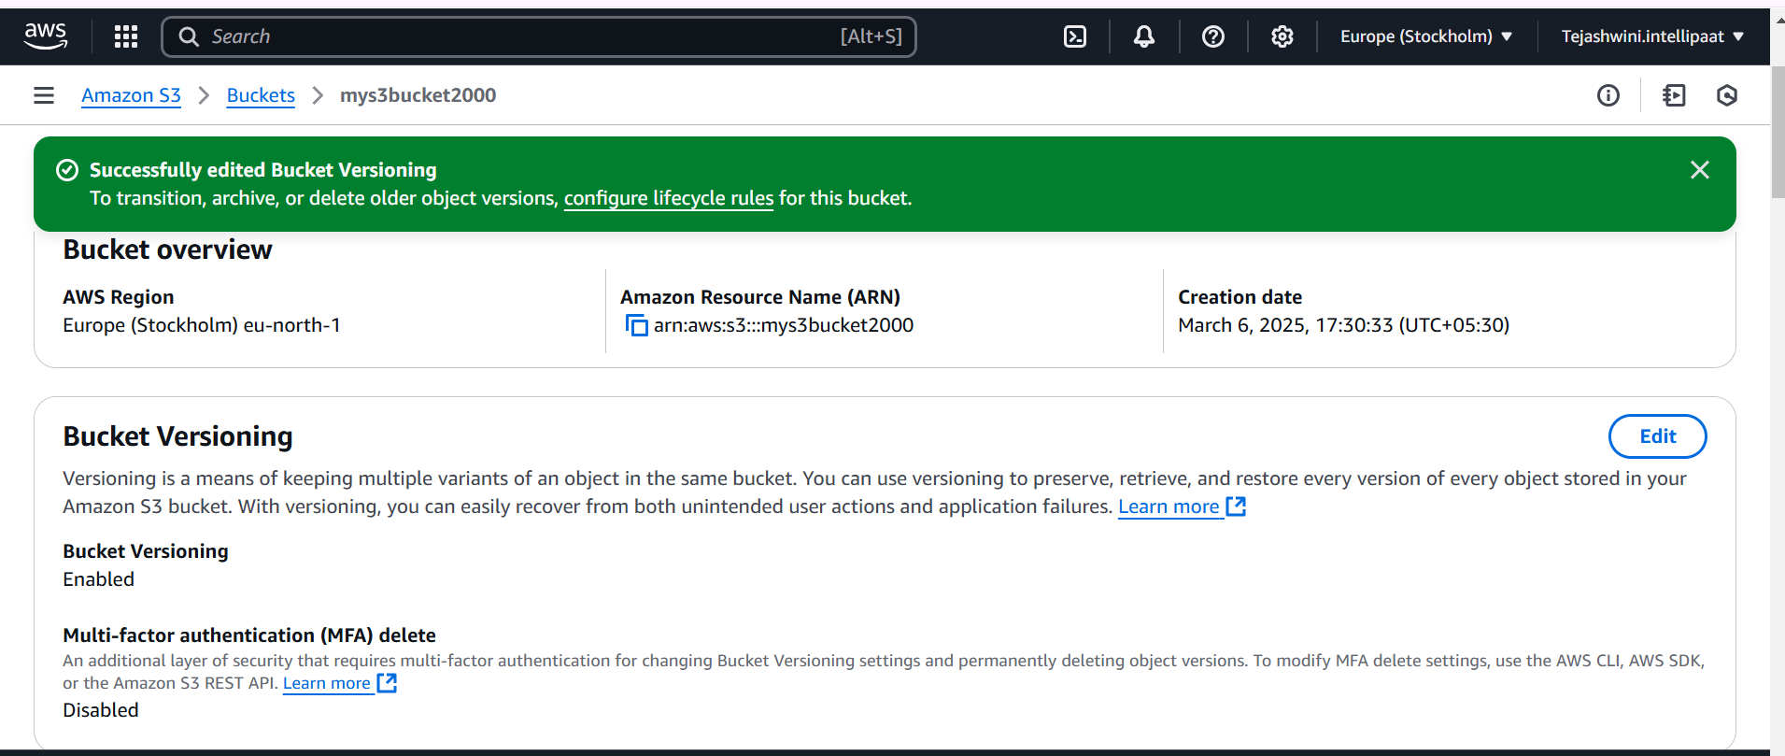

Uploaded 2 more files

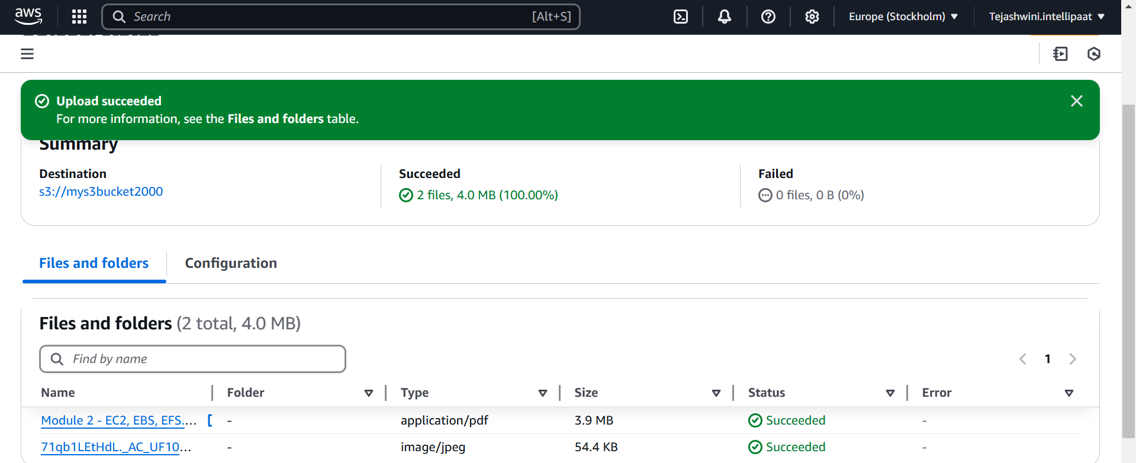

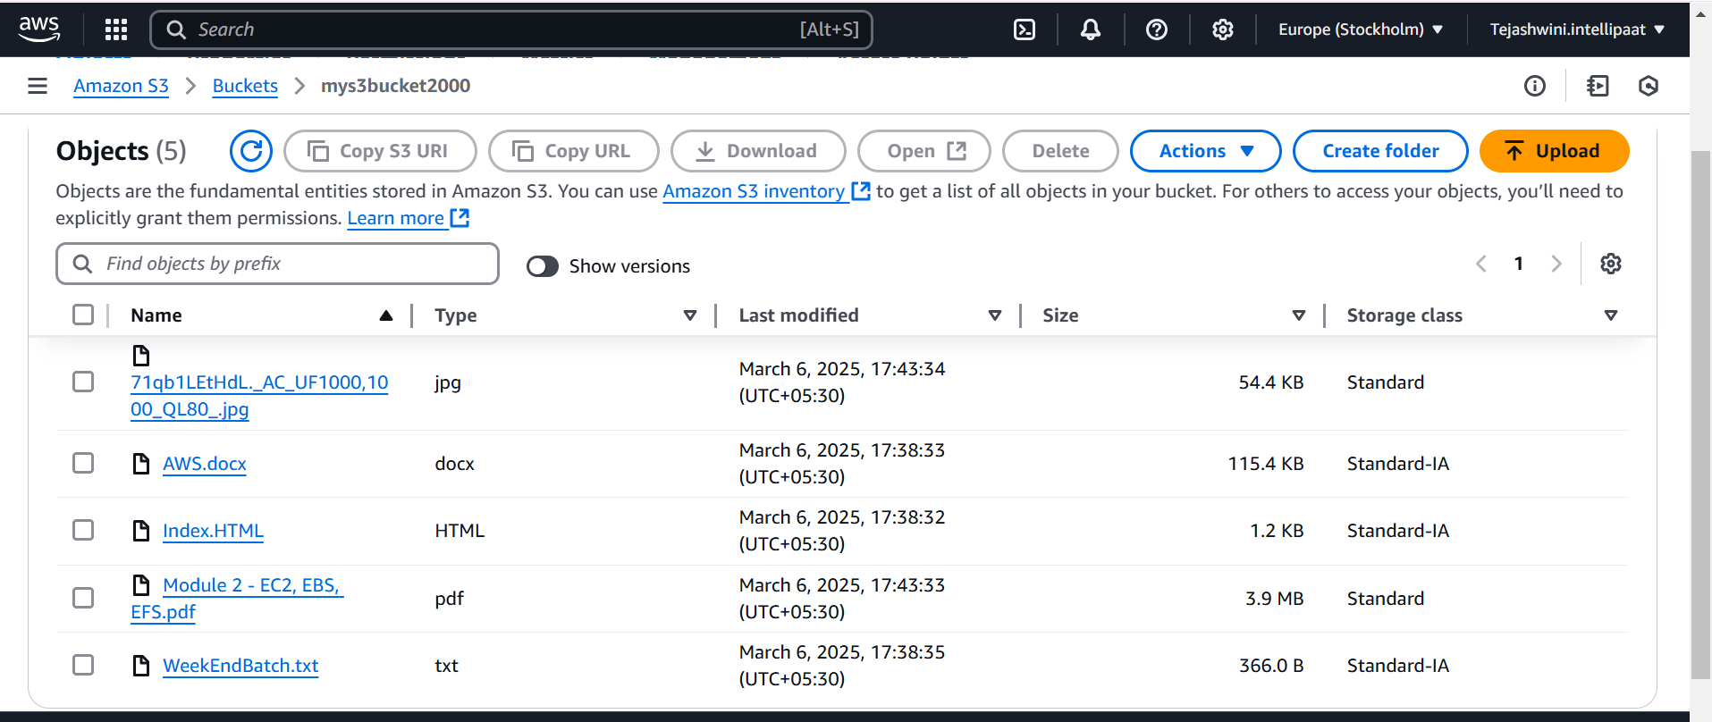

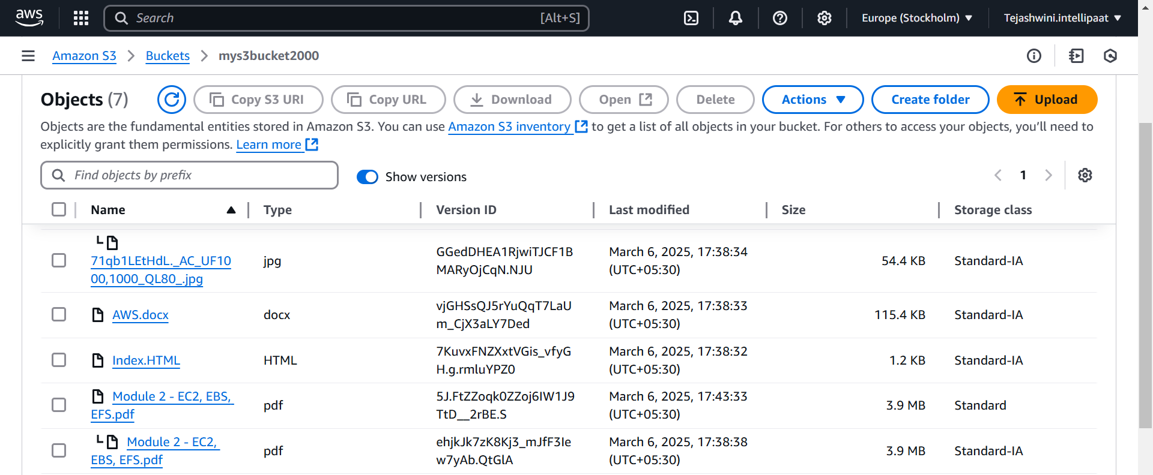

**Task - 3**

**Problem Statement:** You work for XYZ Corporation. Their application requires a storage service that can store files and publicly share them if required. Implement S3 for the same.

**Tasks To Be Performed:**

1. Use the created bucket in the previous task to host static websites, upload an index.html file and error.html page.

2. Add a lifecycle rule for the bucket: a. Transition from Standard to Standard-IA in 60 days b. Expiration in 200 days

Enabled static website hosting

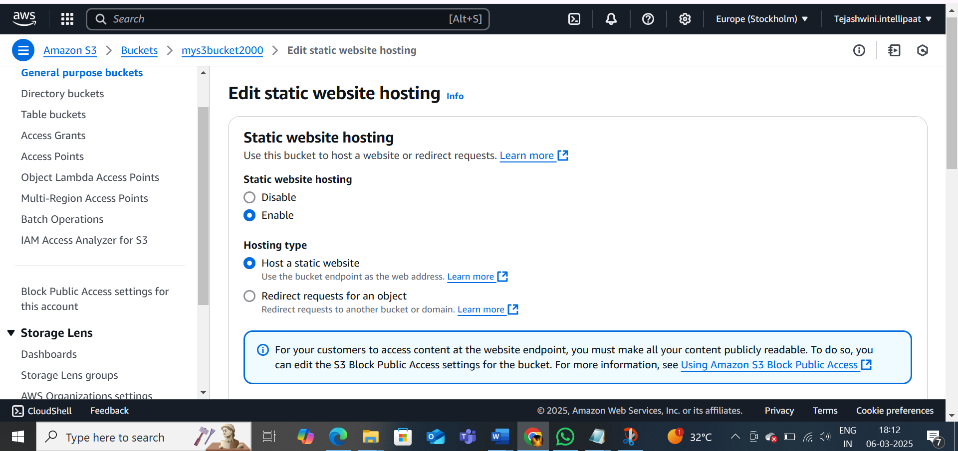

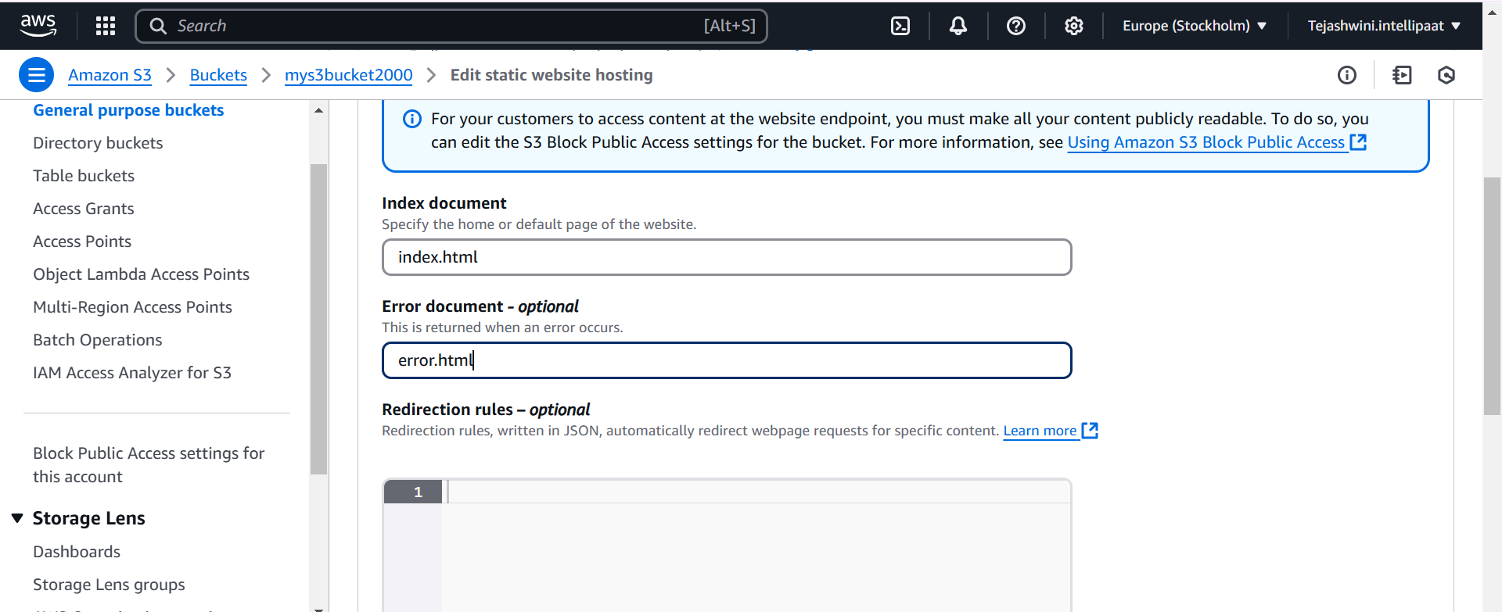

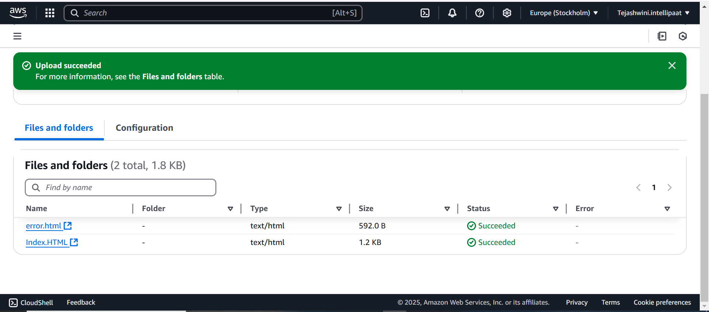

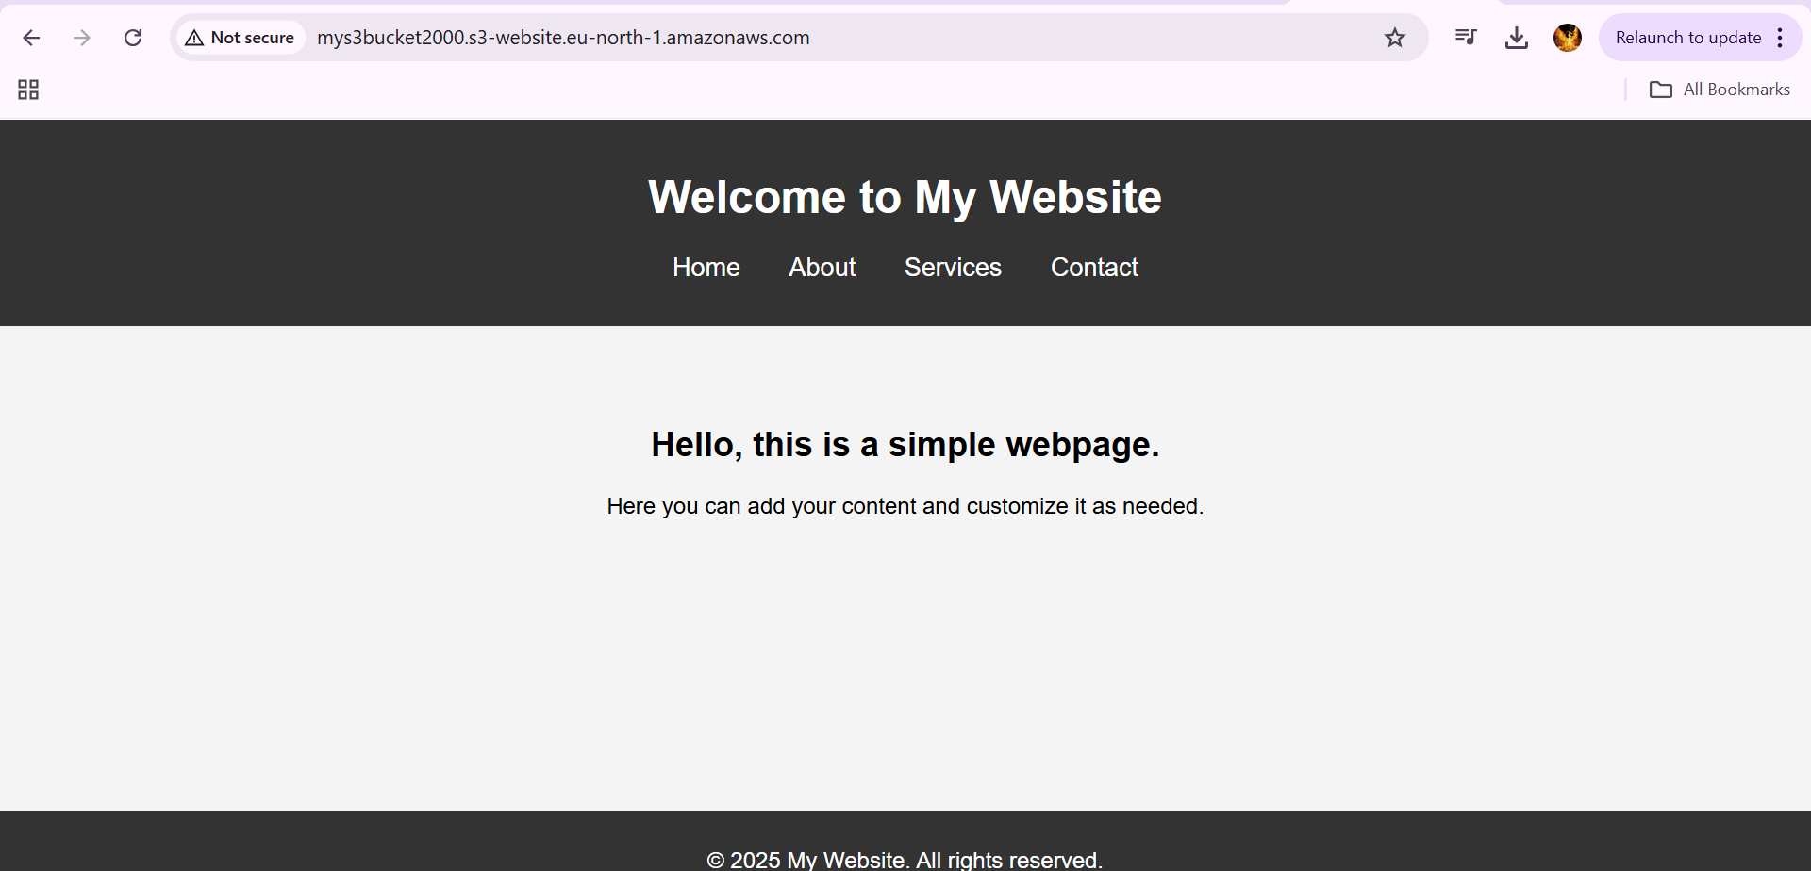

We will get this error if static website is disabled

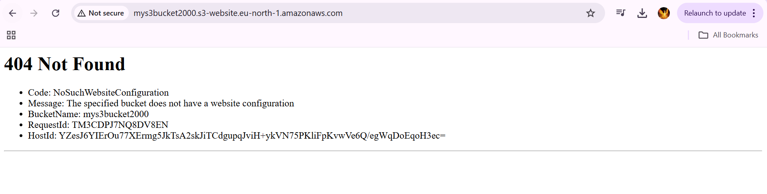

Created lifecycle rule

